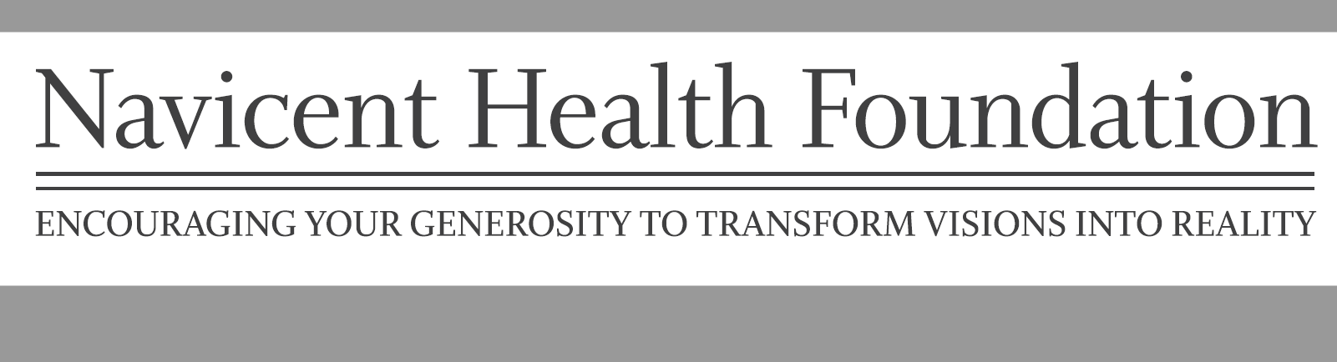

The Grant Allocations Committee of H.E.A.T. (Healthcare Employees Achieving Tomorrow) accepts applications for community grants from the H.E.A.T. Trust Fund. H.E.A.T. is a fundraising program established by and for employees of Navicent Health. On behalf of approximately 2,500 members of H.E.A.T., we proudly share the campaign’s success with our community by annually awarding grants to non-profit organizations and Navicent entities for healthcare projects or programs. Since 1996, the H.E.A.T. Trust Fund has awarded approximately $8 million to improve the health of the communities we serve.

Grant requests which are researched based proposals are not considered.

Funds will be awarded for capital and program costs, but not operational costs.

Grant requests for salaries will be considered on a very limited basis.

Average award amount - $10,000. Additional funds may be awarded based on need and the total number of applications considered in the grant distribution cycle.

Application Procedure

Proposals must be submitted on the official H.E.A.T. Trust Fund Grant Application.

Applicants should follow all directions on the application and include the required supporting documents.

The original application and attached documentation should be mailed to the following address:

Navicent Health Foundation
Attn: Nena Gilreath
PO Box 7718
Macon, GA 31209

The application should also be emailed to Nena Gilreath, Nena.Gilreath@atriumhealth.org

Organizations can only submit one application per year and applications deadline is June 1st.

Selection Process

The HEAT Grant Allocation Committee (GAC) has final approval of all grant requests. This committee is composed of HEAT members. Assistance in assessing proposals may be sought from outside healthcare professionals and/or community representatives.

Following the review of eligible applications, GAC reserves the right to request additional information and/or meet with the applicants. No individual staff member or HEAT member can commit the Foundation; therefore, solicitation of individuals is discouraged.

Notification

Applicant organizations will be informed in writing of GAC decisions. Please do not contact the office directly regarding approval decisions.

Reporting Requirements

Recipient organizations shall report nine months following receipt of the grant unless otherwise stipulated at the time of approval. Failure to report may result in denial of future grants.

Recipient organizations must agree to cooperate with any public announcements, and/or programs arranged in support of HEAT to publicize the benefits of the grant to the community.

Any publications or products derived from funded projects must designate the support received from HEAT.

For more information on HEAT Grants, please contact the Navicent Health Foundation at
478-633-4483.

